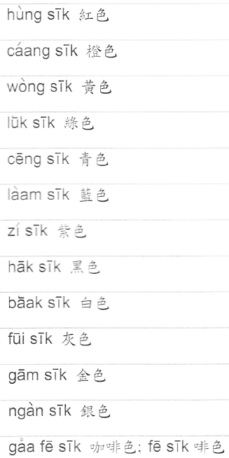
Content extracted from HKU Book on Cantonese learning by Dr. Chow, Esther Bun Ching

